# Frontend Developer Test Assignment

## General description

Create a simple SPA for displaying and adding invoices

## Main view

Contains of a table that gets the list of invoices and displays them along with the **Add New** button. After clicking the **Add new** button user is navigated to the **Create Invoice** view

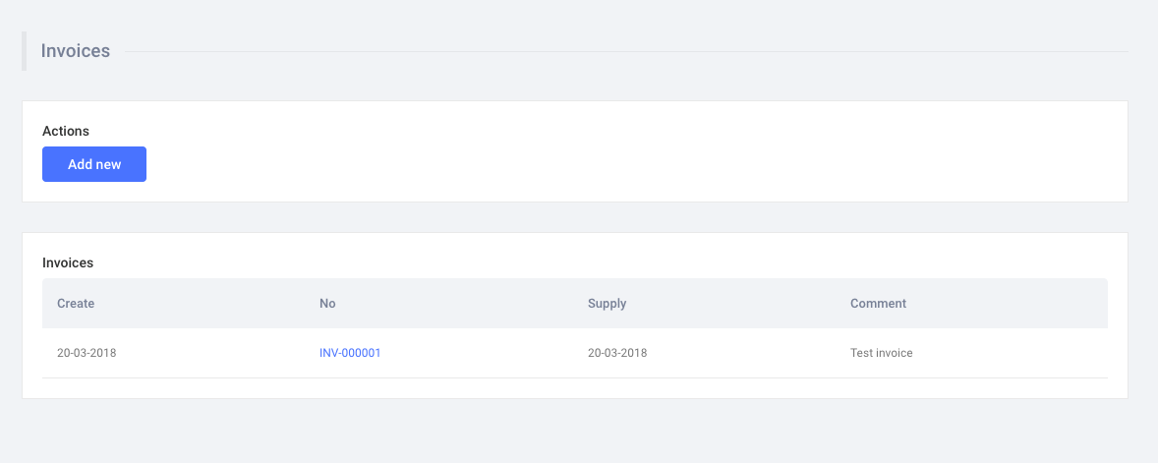

## Create Invoice view

Contains a form that is used for invoice creation. Consists of the following fields:

* Number (text field that should have at least 3 symbols. More sophisticated validation is optional)
* Invoice Date (ISO Date field)
* Supply Date (ISO Date field)
* Comment (text field, should have no more than 160 characters)

After clicking the **Save** button invoice entity is saved and user is navigated to the **Main View**

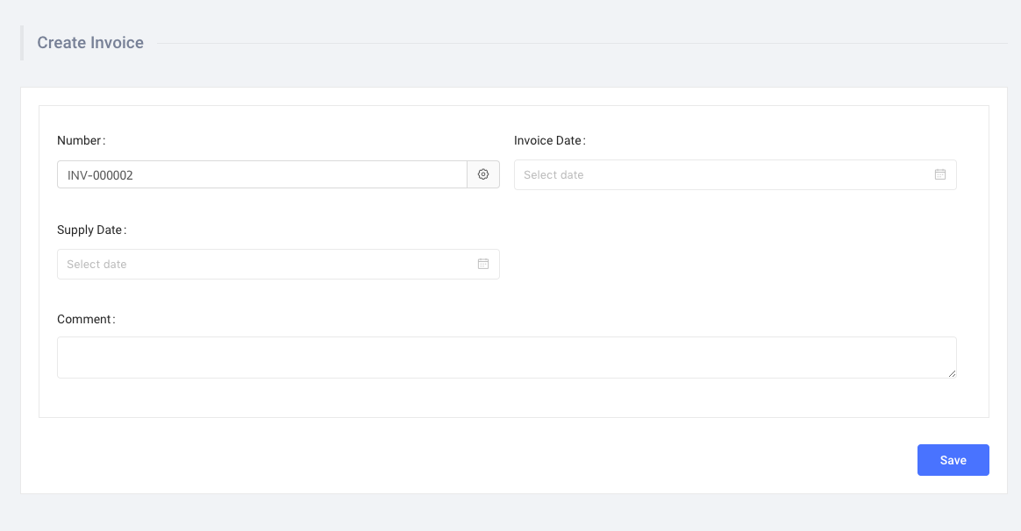

## API

Use the [JSON Server](https://github.com/typicode/json-server) and this initial db.json

1. [
2. {
3. "_id": "5ba37c48185c0c98e6880bed",
4. "number": 63805,
5. "date_created": "23-11-2015",
6. "date_supplied": "20-06-2016",
7. "comment": "ad do labore nisi qui dolore Lorem sint tempor velit"
8. },
9. {
10. "_id": "5ba37c486790868e50ae1d80",
11. "number": 60568,
12. "date_created": "11-07-2017",
13. "date_supplied": "10-12-2016",
14. "comment": "labore eu cupidatat nisi mollit ex laboris ut aliquip deserunt"
15. },
16. {
17. "_id": "5ba37c482a821da190f890a3",
18. "number": 23596,
19. "date_created": "22-08-2016",
20. "date_supplied": "17-11-2015",
21. "comment": "deserunt consectetur eu tempor do aliquip deserunt aliqua do adipisicing"
22. },
23. {
24. "_id": "5ba37c481ebf9bc589fef5d0",
25. "number": 42175,
26. "date_created": "24-09-2014",
27. "date_supplied": "30-06-2018",
28. "comment": "veniam et est aliquip non ut cupidatat occaecat ipsum qui"
29. },
30. {
31. "_id": "5ba37c48c2d8c45a2a04a91e",
32. "number": 88299,
33. "date_created": "18-10-2017",
34. "date_supplied": "24-01-2014",
35. "comment": "do minim elit nulla mollit culpa officia do pariatur ullamco"
36. },
37. {
38. "_id": "5ba37c48671ae1de6d480a60",
39. "number": 40593,
40. "date_created": "27-08-2018",
41. "date_supplied": "12-02-2018",
42. "comment": "eiusmod mollit nostrud aliquip nulla Lorem proident dolore nostrud quis"
43. },
44. {
45. "_id": "5ba37c48c2882eacf4c434f4",
46. "number": 14266,
47. "date_created": "25-12-2017",
48. "date_supplied": "31-10-2016",
49. "comment": "labore eu do dolore deserunt sunt elit nulla magna officia"
50. },
51. {
52. "_id": "5ba37c484d2f231ddf2e824e",
53. "number": 74644,
54. "date_created": "25-11-2016",
55. "date_supplied": "15-07-2017",
56. "comment": "amet consequat adipisicing mollit eu nostrud anim pariatur eiusmod ullamco"
57. },
58. {
59. "_id": "5ba37c48e44ac4fed3bc9d41",
60. "number": 55509,
61. "date_created": "16-02-2014",
62. "date_supplied": "29-08-2015",
63. "comment": "duis sint culpa magna adipisicing id id Lorem minim ad"
64. },
65. {
66. "_id": "5ba37c486024775344d497e6",
67. "number": 18041,
68. "date_created": "30-01-2018",
69. "date_supplied": "05-06-2016",
70. "comment": "incididunt esse amet reprehenderit in exercitation in incididunt exercitation aliqua"
71. }
72. ]

## Requirements

* Use HTML5 and SCSS
* Make it responsive using your best judgement
* Use Vanilla JavaScript or React
* Adhere to the mockups as much as possible
* Don’t use any CSS Frameworks
* Make sure that HTML is valid while markup is semantically correct

## Coding standards

When working on the project use consistent coding style. Use the following tools to ensure code cleanliness:

* [Prettier](https://prettier.io/) – code formatter
* [ESLint](https://eslint.org/) – JavaScript linter
* [Stylelint](https://stylelint.io/) – CSS linter

## Optional tasks

Add actions column that will contain **Edit** and **Remove** options for each of the invoice rows:

* **Edit** button will trigger **Edit Invoice View** display that will be the same as the **Create Invoice View**, but should contain prepopulated data from the chosen invoice
* **Remove** button deletes the invoice

## Browser support

Ensure that the elements work and display correctly in the following browsers:

* Firefox (latest version)
* Google Chrome (latest version)
* Microsoft Edge